Incident Investigation Report HSE-INC-2026-018
Dropped object near miss on MV Sea Atlas, 3 June 2026
Hannah Weber · 19 June 2026 · HSE-INC-2026-018
Field | Details
Incident no. | HSE-INC-2026-018
Date / time | 3 June 2026, 10:47
Location | Main deck, MV Sea Atlas, at HB-A08
Classification | Near miss – high potential (dropped object)
Injuries | None
Investigation lead | Yusuf Demir (Weyland) with Atlas Marine HSE Manager
Report approved | Hannah Weber, 19 June 2026

1. Summary
During rigging for the lift of the transition piece for HB-A08, a shackle pin (2.8 kg) fell approximately 18 m from the crane block onto the main deck. It landed 3 m from a deck crew member who was outside the marked drop zone. Nobody was injured. Using the DROPS calculator, a 2.8 kg object falling 18 m is in the fatal category. The event was therefore classified as a high-potential near miss.
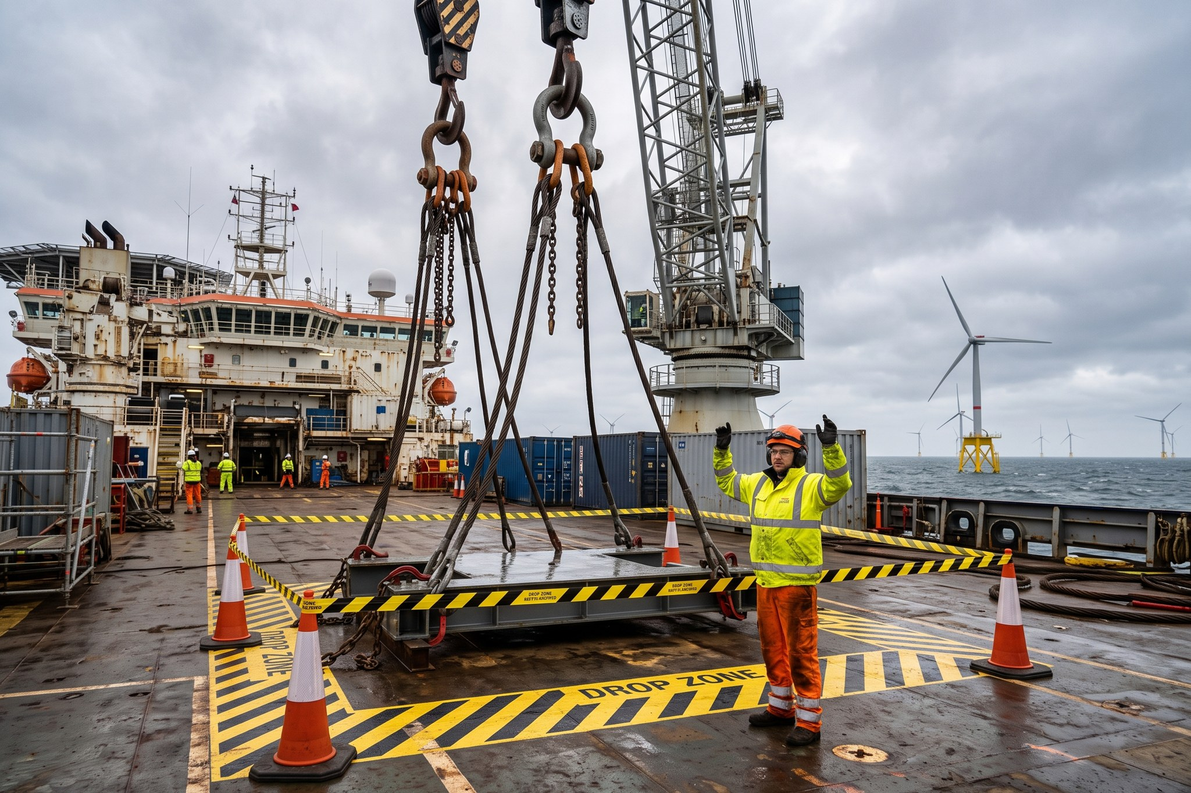
Rigging area on the main deck of MV Sea Atlas (reconstruction after the event)

2. Sequence of events
Time | Event
09:30 | Toolbox talk for TP lift; drop zone 10 m radius marked
10:20 | Crane block lowered, rigging crew attached the four-leg sling set
10:41 | Crane block raised to 18 m to clear the TP davit
10:47 | Shackle pin fell from the bow shackle on sling leg 3
10:48 | All-stop called by the banksman; area secured
11:05 | Lifting operations suspended by the Master
14:00 | HSE Manager Hannah Weber notified; Project Director and Steering Committee chair informed
4 Jun 20:47 | Lifting resumed after 34 hours following DROPS inspection and safety stand-down

3. Root cause analysis
The investigation used the ICAM method. The direct cause was a bow shackle with a missing split pin (secondary retention), so the nut worked loose under vibration and the pin dropped out when the sling became slack.
- Immediate cause: missing split pin on safety bolt shackle (WLL 55 t).
- Underlying cause 1: the pre-use inspection checklist for rigging did not include a check of secondary retention.
- Underlying cause 2: rigging from two suppliers was mixed on board; one supplier delivers shackles with split pins pre-installed, the other does not.
- Contributing factor: the drop zone radius (10 m) did not account for the height of the crane block above the TP davit.

4. Corrective actions
# | Action | Owner | Due | Status
1 | Add secondary retention check to rigging pre-use checklist | Atlas Marine | 10 Jun | Closed
2 | Quarantine and inspect all shackles on board (412 items) | Atlas Marine | 5 Jun | Closed
3 | Standardise rigging supplier for Harrow Bay | Laura Kessler | 15 Jul | Closed
4 | Drop zone radius = 1/2 lift height, min. 10 m | Felix Brandt | 10 Jun | Closed
5 | DROPS awareness training for all deck crew | Yusuf Demir | 30 Jun | Closed
6 | Share learning with all contractors and Kestrel Ridge | Hannah Weber | 15 Jul | Closed
7 | Monthly DROPS inspection of crane block and rigging store | Atlas Marine | ongoing | Closed – in place
8 | Update HB-RISK-009 in project risk register | Elena Márquez | 30 Jun | Closed

5. Lessons learned
A small, routine item – a split pin – nearly caused a fatality. Secondary retention must be checked every time, not only at the six-monthly thorough examination. The good practice of keeping people outside the drop zone worked, but the zone was too small. The crew member involved has been thanked for reporting openly, and the banksman for the immediate all-stop.

